Pre Test Grade 5 Numbers and Operations Base 10
#1. Round 85,299 to the nearest 1000 ____________________
#2. Round 32,879 to the nearest 1000 ____________________
#3. Round 77 to the nearest 10 ____________
#4. Write this number in Expanded Notation: 34,709
_____________________________________________________________________________________
#5. Write this number in Word Form: 54,921
_____________________________________________________________________________________
#6. Write this number in Standards Form: eighty five thousand two hundred sixty three.
_____________________________
#7.
Which figure represents number 3,000?
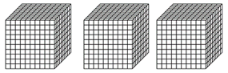
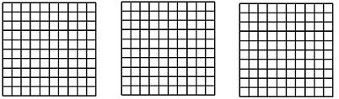

#8.
Digit 5 in whole number 752 represents
Ones
Tens
Hundreds
# 9. How many ones are in fourteen? _____________

#10.
If you divide a block of 50 by 10
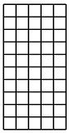
how many blocks of ten you would have?
(block of ten)
# of blocks of ten =

