Virtual Vacation Trip Planning
Who will be going on this vacation? Names of Travel members________________________________
_____________________________________________________________________________
What is your Destination? _________________________________________________________
Using Google
What are the total miles of your trip? _____________.
Total number of hours Traveling? ____________.
In order to find total mileage, log on to the computer, go to google maps, click on “get directions” enter the starting point of the trip “Kansas City”, then enter your destination city. Write down the total miles, also write the total number of hours you will need to travel.
Time to Look at Your Route
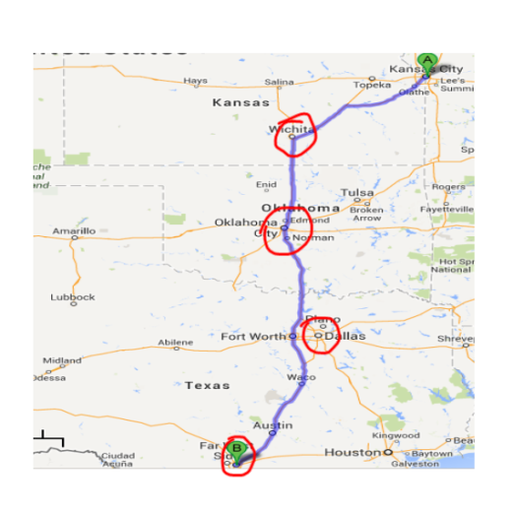
Your trip needs to include several stops along the way. Once you have google maps which show your travel route look at it to find cities along the way in which you would like to stop and or go site seeing, spend the night or other activities.
Example: I see that I could stop in Wichita, Oklahoma City, or Fort Worth Texas. But I would really like to go to Dallas.
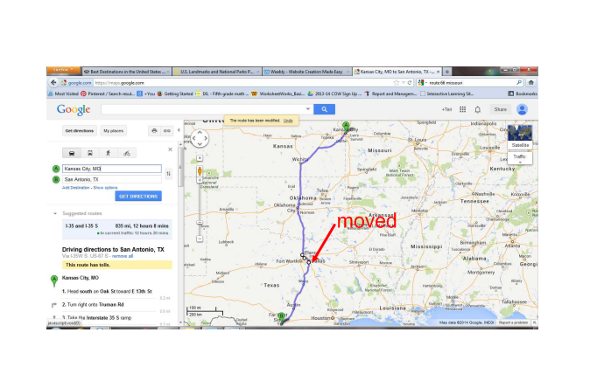
If you see a city that is close to your route, you can use your mouse to click and drag the route to a different city. You will need to recheck your travel miles as well as your travel time and make corrections to your trip information.

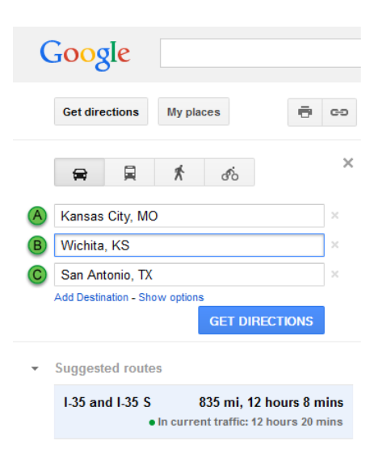
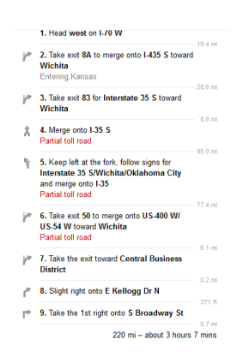
Now it is time to find out the mileage and travel time between your stopping cities. You will do this by adding destinations to your google map. You can grab the letter and move it into the correct order in your trip. If you look down in the direction you will see that it gives the mileage for each destination after the directions.

Starting City  Example Kansas City | Stopping City  Wichita Kansas | Miles between Cities  220 miles | Hours of Travel  3 hours 7 min
First leg of the trip from….. | to
Second leg of the trip from... | t0
Third leg of the trip from… | to
Fourth leg of the trip from… | to
Last leg of the trip from…. | to

Selecting a Car
Calculating miles, planning gas stops

You will be selecting a vehicle in which you will use to travel. You will need to consider the amount of miles per gallon a car needs in gas. This factor will determine how often you need to stop and refill on your trip and how much it will cost you in gas to travel. You will first need to look at the “Select a Car” website at (stevensonj.net).

Select Your Car

My Car is the ________________________________________

Cars Miles per Gallon Highway ____________________________

Tank Capacity 15 gallon tank formula Miles per Gallon X Tank Capacity = Miles traveled
MPG x C = Total Miles

___ ___

X 1 5
Total miles you can travel

You now need to look back at your daily travel schedule,
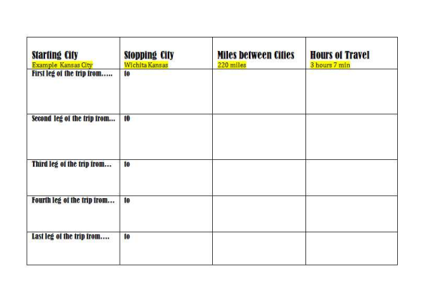
With the miles you can travel decide how far on your journey you can travel with your first tank of gasoline. Decide on a city in which you would stop in order to fill up with gas.
Google the name of the City with price of gas after the name, example (Dodge City, Kansas gasoline prices).

You will also need to know how many miles you traveled from your last stop to the gas station in which you just filled up. You can do this by Googling the start city and your gas stop city. (Just Like getting mileage before)
Name of City You are stopping to fill up on gas | Price of Gas In that City per  1 Gallon | Price of Gas you will pay to fill up your tank, “15 gallons” | How many miles you have traveled on the previous tank of gas
Stop #1

Stop #2

Stop #3

Stop #4

Overnight Accommodations
Time to plan for your overnight stays. You will now have to select your hotel or form of lodging. You can choose to stay in a hotel, motel, or campsite. You will need to find the price per night for a stay in the facilities.
In order to do this you need to google your stopping city again but include hotel, motel, or campgrounds. Example: (Indianapolis, Indiana campgrounds)
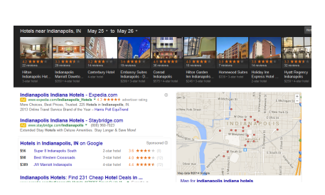
You can choose a hotel from the ribbon at the top of the page or you can choose
a hotel from the google map, select one of the hotel bubbles. If you are going to camp you do the same process, except type “Campgrounds” after the name of your city.
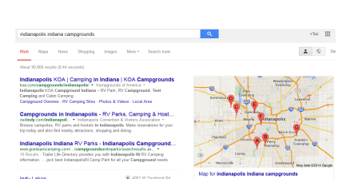Click on a bubble to choose a campsite.
Name of City | Name of Hotel, Motel or Campground | Price Per Night | Price of multiple night stays.

Sight Seeing- Attractions

