Selecting a Car
Calculating miles, planning gas stops

You will be selecting a vehicle in which you will use to travel. You will need to consider the amount of miles per gallon a car needs in gas. This factor will determine how often you need to stop and refill on your trip and how much it will cost you in gas to travel. You will first need to look at the “Select a Car” website at (stevensonj.net).

Select Your Car

My Car is the ________________________________________

Cars Miles per Gallon Highway ____________________________

Tank Capacity 15 gallon tank formula Miles per Gallon X Tank Capacity = Miles traveled
MPG x C = Total Miles

___ ___

X 1 5
Total miles you can travel

You now need to look back at your daily travel schedule,
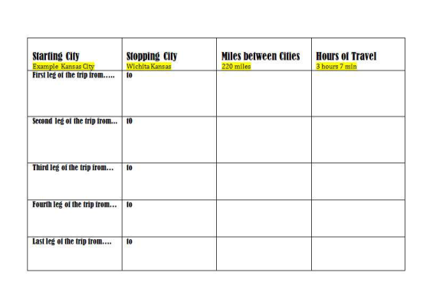
With the miles you can travel decide how far on your journey you can travel with your first tank of gasoline. Decide on a city in which you would stop in order to fill up with gas.
Google the name of the City with price of gas after the name, example (Dodge City, Kansas gasoline prices).

You will also need to know how many miles you traveled from your last stop to the gas station in which you just filled up. You can do this by Googling the start city and your gas stop city. (Just Like getting mileage before)
Name of City You are stopping to fill up on gas | Price of Gas In that City per  1 Gallon | Price of Gas you will pay to fill up your tank, “15 gallons” | How many miles you have traveled on the previous tank of gas
Stop #1

Stop #2

Stop #3

Stop #4

